**Getting MySQL to work for VSCode**

1. Install MySQL:

* Ensure to remember your user and passwords
* Download: <https://dev.mysql.com/downloads/windows/installer/>
* Video: <https://www.youtube.com/watch?v=WuBcTJnIuzo>

1. Install JDBC:

* Download: <https://dev.mysql.com/downloads/connector/j/5.1.html>
* Video: <https://www.youtube.com/watch?v=2i4t-SL1VsU>

1. Create a “lib” folder in the Java project directory and paste the “mysql-connector-java-5.1.48-bin.jar” file from the JBDC download into it.

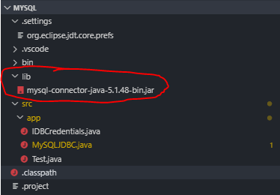

1. Add the “mysql-connector-java-5.1.29-bin.jar” file from the JDBC download into the Java project classpath.

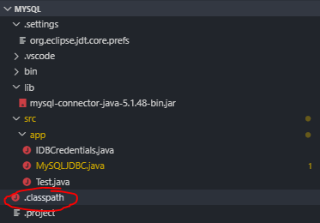

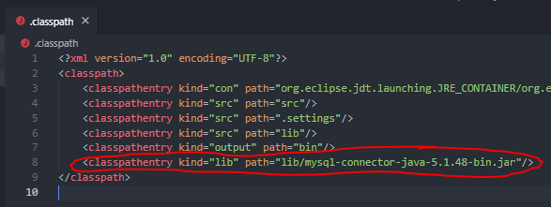

1. Open MySQL workbench and enter the query “ALTER USER 'root'@'localhost' IDENTIFIED WITH mysql_native_password BY 'PASSWORD'”

* Note that “PASSWORD” should be replaced by your personal MySQL password

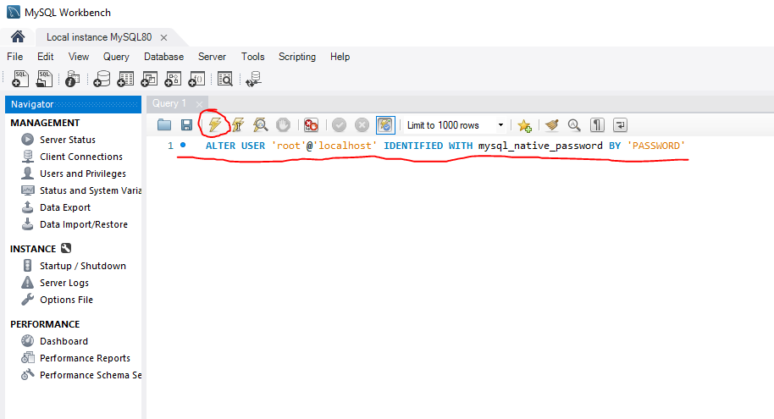

1. Test your connection by downloading the SQLTools VSCode extension

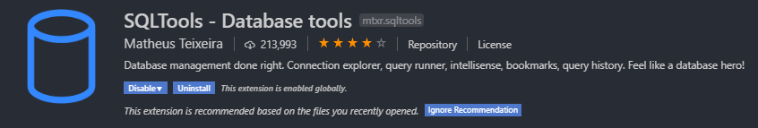

* Add new connection

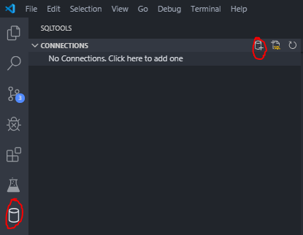

* Select MySQL

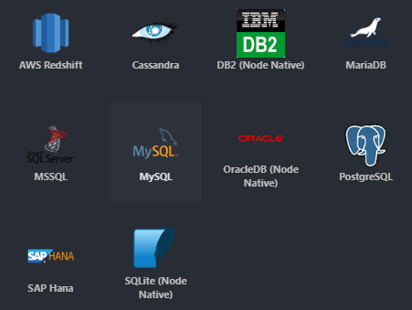

* Input credentials and press “Save Connection”
  + Connection Name can be anything
  + Database “world” is one of the pre-set databases that comes after downloading MySQL. You can see it using MySQL Workbench (See Appendix A)
  + Note that “PASSWORD” should be your personal MySQL password

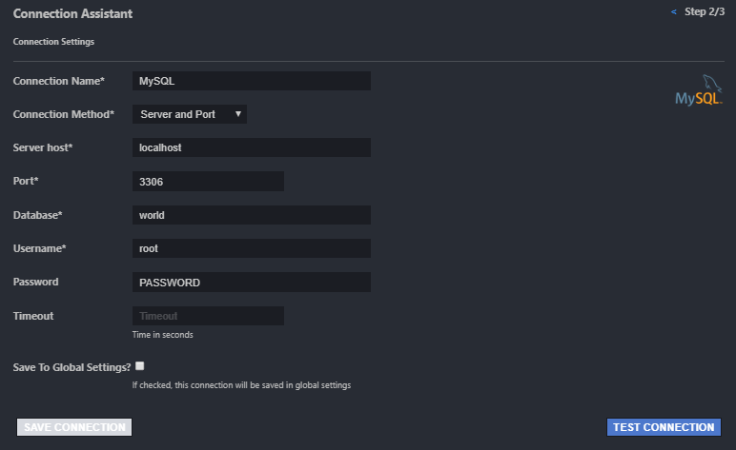

1. If successful, you should see something like the following:

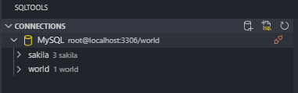

**Appendix A**

